Group: Liang Li, Yingfa He, Quintus J Lin

**E-R Data Model:**

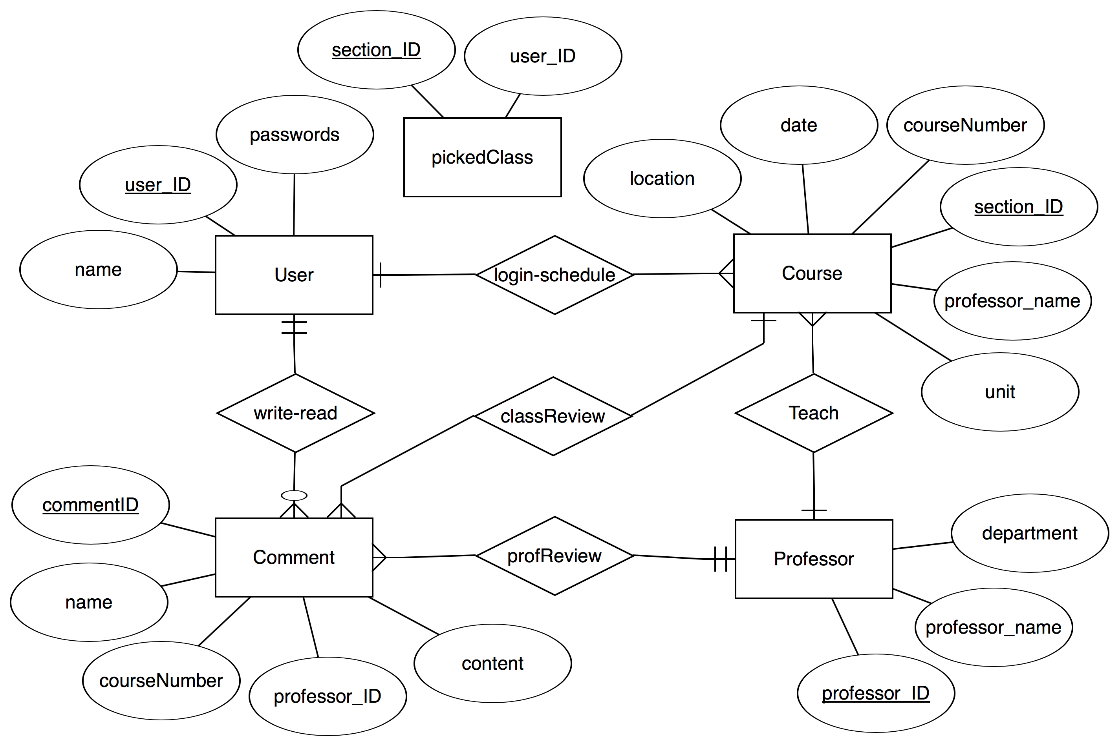

**Relational Data Model:**

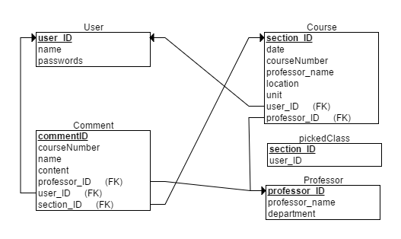

pickedClass (sectionID, userID) *primary key: sectionID*

User (userID, passwords, name) *primary key: userID*

Course (sectionID, courseNumber, professorName, date, location, unit, userID, professorID) *primary key: sectionID*

Comment (commentID, name, courseNumber, professorID, content, userID, sectionID) *primary key: commentID*

Professor (professorID, professorName, department) *primary key: professorID*

**Logical Design:**

sectionID CHAR(5) 12863

userID CHAR(10) liangli890

userID CHAR(10) liangli890

passwords VARCHAR(20) LETITGO

name CHAR(15) Lee Sin

sectionID CHAR(5) 12863

courseNumber CHAR(6) CSC430

professorName CHAR(15) Zhang

date DATE 09 Oct 2016 11:11:11:111

location CHAR(6) 1N-005

unit INT 5

userID CHAR(10) liangli890

professorID CHAR(5) 12345

commentID CHAR(5) JF321

name CHAR(15) Lee Sin

courseNumber CHAR(6) CSC430

professorID CHAR(5) 12345

content VARCHAR(50) “TAKE THIS COURSE!”

userID CHAR(10) liangli890

sectionID CHAR(5) 12863

professorID CHAR(5) 12345

professorName CHAR(15) Lee Sin

department CHAR(20) Computer Science

**Physical Design:**

CREATE TABLE User

(

userID CHAR(10) NOT NULL,

name CHAR(15) NOT NULL,

passwords VARCHAR(20) NOT NULL,

PRIMARY KEY (userID)

);

CREATE TABLE Professor

(

professorID CHAR(10) NOT NULL,

professorName CHAR(15) NOT NULL,

department CHAR(20) NOT NULL,

PRIMARY KEY (professorID)

);

CREATE TABLE pickedClass

(

sectionID CHAR(5) NOT NULL,

userID CHAR(10) NOT NULL,

PRIMARY KEY (sectionID)

);

CREATE TABLE Course

(

sectionID CHAR(5) NOT NULL,

courseNumber CHAR(6) NOT NULL,

professorName CHAR(15) NOT NULL,

location CHAR(6) NOT NULL,

date DATE NOT NULL,

unit INT NOT NULL,

userID CHAR(10) NOT NULL,

professorID CHAR(5) NOT NULL,

PRIMARY KEY (sectionID),

FOREIGN KEY (userID) REFERENCES User(userID),

FOREIGN KEY (professorID) REFERENCES Professor(professorID)

);

CREATE TABLE Comment

(

commentID CHAR(5) NOT NULL,

name CHAR(15) NOT NULL,

courseNumber CHAR(6) NOT NULL,

content VARCHAR(50) NOT NULL,

professorID CHAR(5) NOT NULL,

userID CHAR(10) NOT NULL,

sectionID CHAR(5) NOT NULL,

PRIMARY KEY (commentID),

FOREIGN KEY (professorID) REFERENCES Professor(professorID),

FOREIGN KEY (userID) REFERENCES User(userID),

FOREIGN KEY (sectionID) REFERENCES Course(sectionID)

);